**Eshelby Method of Inclusions**

To consider the elastic strain energy of our sample, Eshelby’s method of inclusions can be used. Eshelby’s method decomposes the presence of the inclusion and how the inclusion affects the elastic strain field into a sequence of elementary steps, which are pictorially shown below. A key foundation of Eshelby’s argument is the concept of linear elasticity: for infinitesimally small strains, the stress is linearly proportional to the strain. As a stress-strain plot shows, linear elasticity clearly only applies for small strains that do not exceed yielding.

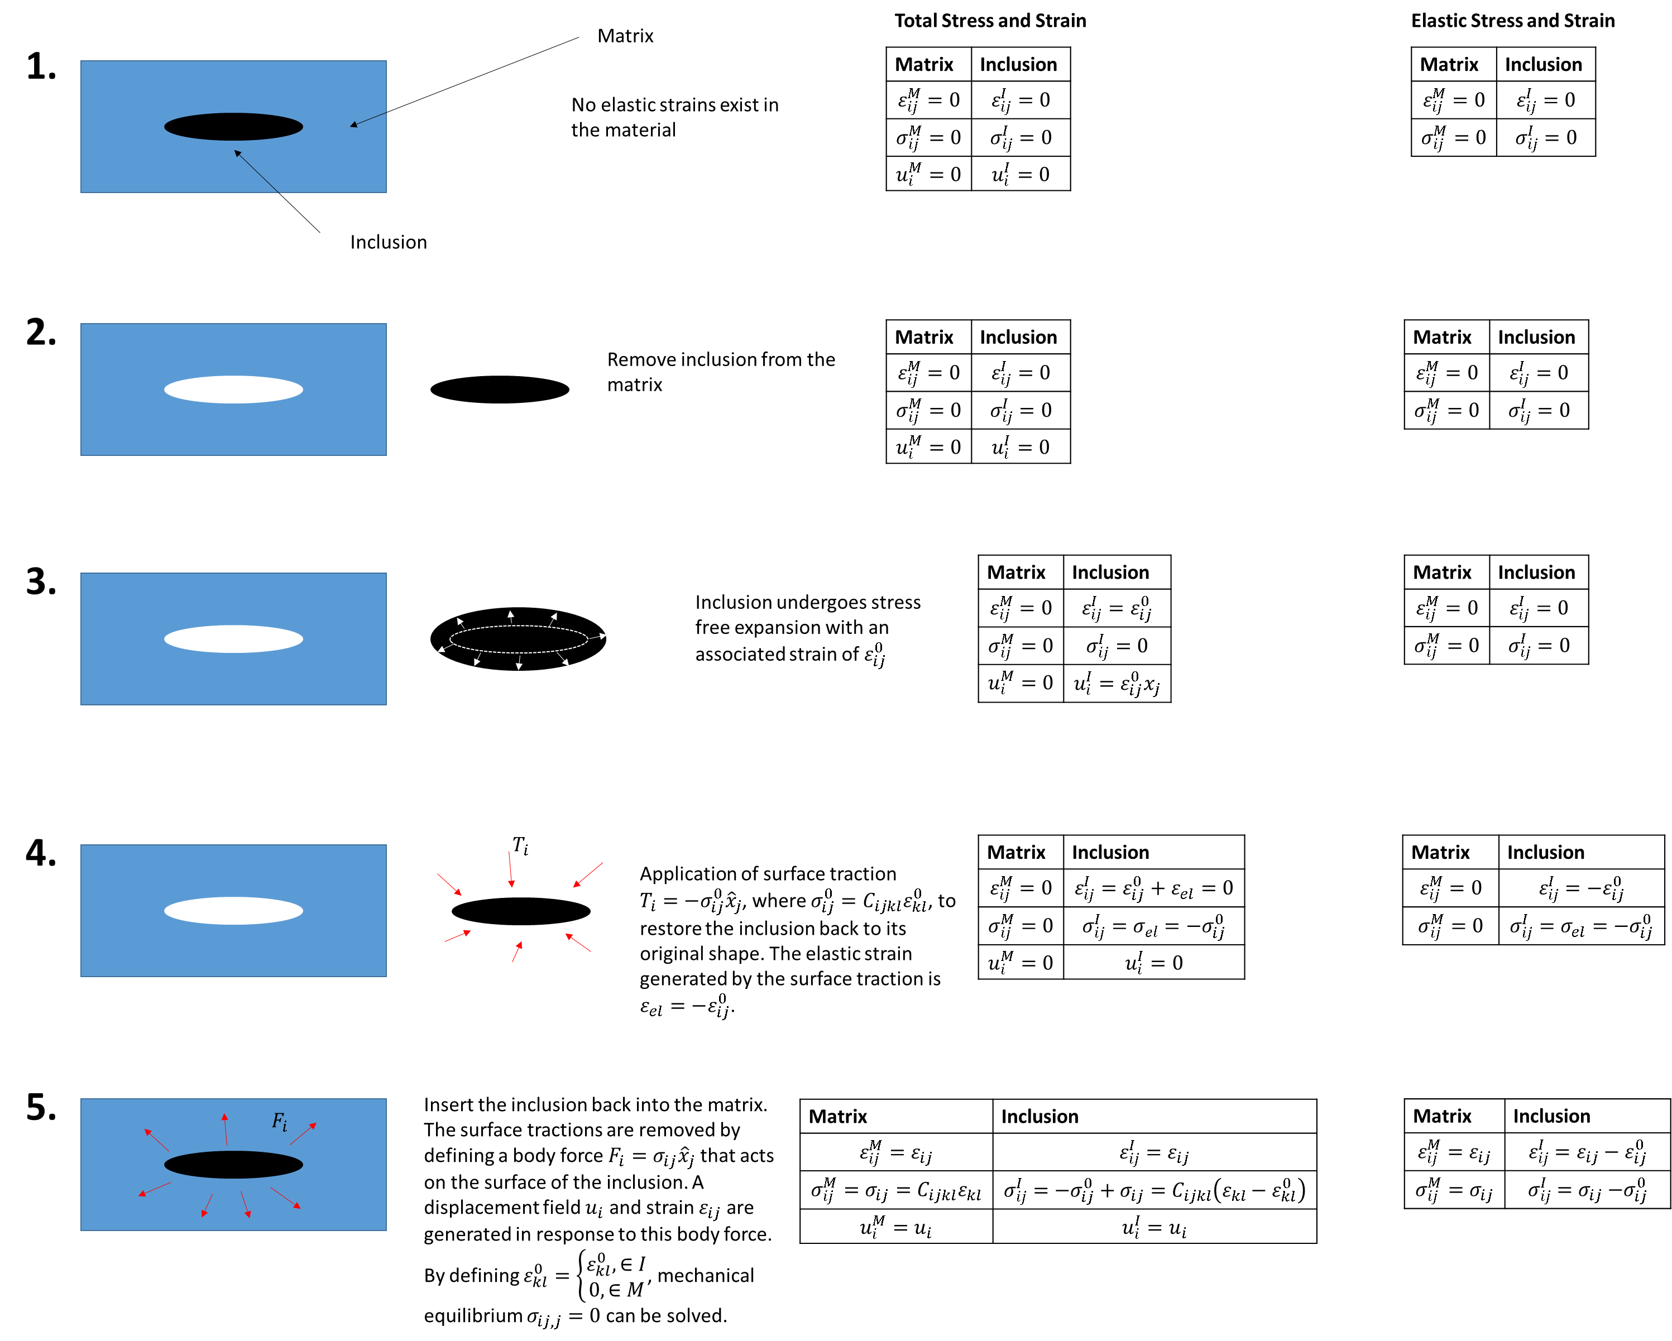

The starting point in Eshelby’s method is an unstrained and unstressed matrix with an inclusion. We want to calculate the free energy change when we allow elastic strains to form. In Eshelby’s method, the inclusion is cut out of the matrix and allowed to expand in a stress free transformation with associated strain $ε_{ij}^{0}$, which is called the eigenstrain. The eigenstrain is not an elastic strain because it is not due to reversible, elastic deformation. The inclusion is then reinserted into the matrix by application of an eigenstress $σ_{ij}^{0}=C_{ijkl}ε_{kl}^{0}$. This eigenstress is applied as a surface traction, a force applied along the surface of the inclusion. This surface traction returns the inclusion to its original shape and generates an elastic strain $ε_{el}=-ε_{ij}^{0}$ and elastic stress $σ_{el}=-σ_{ij}^{0}$. The inclusion is then inserted into the void from which it is removed. Once the inclusion is inserted, the surface traction is removed by application of a body force equal and opposite to the previously applied surface traction. This body force is only applied to the surface of the inclusion, but is called a body force because the forces are internal to the volume. The body force leads to internal stresses. These internal stresses contribute to an additional, so-called “constrained” displacement and, thus strain, field. The constrained field is also called the relaxation field in some cases. The total stress field within the material can be expressed as: $σ_{ij}=C_{ijkl}\left(ε_{kl}-ε_{kl}^{0}\right),$ where $ε_{kl}^{0}=0$ outside the inclusion, $ε_{kl}^{0}=ε_{kl}^{0}$ within the inclusion, and $ε_{kl}$ is the constrained strain field generated by the body force. Cauchy’s First Law of Motion allows us to impose the mechanical equilibrium condition of (assuming a spatially unvarying elastic tensor):

$$σ_{ij,j}=C_{ijkl}\left(ε_{kl,j}-ε_{kl,j}^{0}\right)=0$$

Assuming mechanical relaxation is faster than polarization relaxation, the mechanical equilibrium equation can be solved to obtain the strain field. This simplifies the TD-LGD equation by eliminating the strain order parameter. We can use Eshelby’s method to calculate the elastic strain energy of ferroelectrics. The stress free transformation strain is obtained by solving for $ε_{ij}^{0}$ in the below equation:

$${\left.\frac{δF}{δε_{ij}}\right|}_{ε_{ij}=ε_{ij}^{0}}=σ_{ij}=0.$$

**Homogenous and Heterogeneous Strain**

To solve the mechanical equilibrium equation, we consider the system to be macroscopically homogenous. That is, we divide our macroscopic sample into small volumes. These volumes are what we will numerically simulate [http://www.mse.berkeley.edu/groups/morris/MSE205/Extras/Elastic-Inclusions.pdf, JW Morris Jr The Khachaturyan theory of elastic inclusions: Recollections and results]. In other words, “the inclusions are distributed in a macroscopically homogenous pattern in which every macroscopic subvolume of the system is sensibly the same” [http://www.mse.berkeley.edu/groups/morris/MSE205/Extras/Elastic-Inclusions.pdf]. In this case, we need only consider one subvolume to approximate the total volume.

To solve the mechanical equilibrium equation, we define

$$ε_{ij}\left(\vec{x}\right)={\overline{ε}}_{ij}+δε_{ij}\left(\vec{x}\right)$$

$$σ_{ij}\left(\vec{x}\right)={\overline{σ}}_{ij}+δσ_{ij}\left(\vec{x}\right)$$

$${\overline{σ}}_{ij}=C_{ijkl}{\overline{ε}}_{kl}$$

$$δσ_{ij}=C_{ijkl}\left(δε_{ij}-ε_{ij}^{0}\right)$$

with

$$\int{δε_{ij}\left(\vec{x}\right)}d\vec{x}=0$$

$$\int{δσ_{ij}\left(\vec{x}\right)}d\vec{x}=0$$

The above definition is mathematically sound because the average values can be readily determined:

$${\overline{ε}}_{ij}=\int{ε_{ij}(\vec{x})}d\vec{x}$$

$${\overline{σ}}_{ij}=\int{σ_{ij}(\vec{x})}d\vec{x}$$

${\overline{ε}}_{ij}$ and ${\overline{σ}}_{ij}$ are called the homogeneous strain and stress respectively. ${δε}_{ij}$ and ${δσ}_{ij}$ are called the heterogeneous strain and stress respectively. Physically, within our macroscopic homogeneity approximation, our sample consists of multiple subvolumes. Each subvolume has the same homogenous stress ${\overline{σ}}_{ij}$ and strain ${\overline{ε}}_{ij}$, giving the entire sample stress ${\overline{σ}}_{ij}$ and strain ${\overline{ε}}_{ij}$. Note that if we have $N$ subvolumes and each subvolume has strain ${\overline{ε}}_{ij}$, the total macroscopic strain is not $N{\overline{ε}}_{ij}$, but rather ${\overline{ε}}_{ij}$.

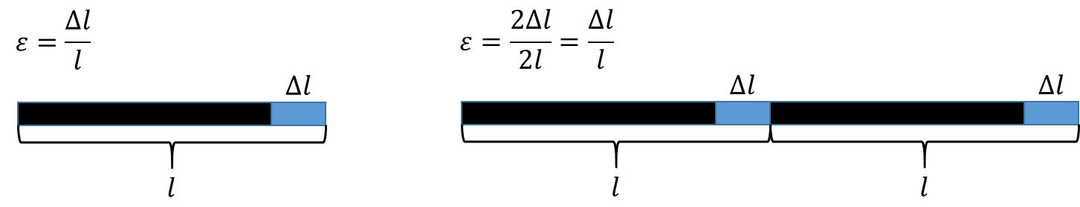

Physically, the homogenous strain affects the macroscopic body dimensions. The local, heterogeneous strain does not affect the overall body dimensions (its average over the volume is zero [A.G. Khachaturyan, Elastic Strain Energy of Inhomogeneous Solids PRB 52, 22, 1995]. Because the homogenous strain acts macroscopically, we can use Hooke’s law:

$${\overline{σ}}_{ij}=C_{ijkl}{\overline{ε}}_{ij}$$

The heterogeneous stress/strain relation is:

$$δσ_{ij}=C_{ijkl}\left(δε_{ij}-ε_{ij}^{0}\right)$$

because $σ_{ij}=C_{ijkl}e_{kl},$ where $e_{kl}$ is the elastic strain. Later we will show that the elastic strain is $ε_{ij}-ε_{ij}^{0}.$

We also define a spatially varying displacement field $u_{i}^{T}\left(\vec{x}\right)$, such that:

$$u_{i}^{T}\left(\vec{x}\right)=\overline{u_{i,j}}x_{j}+u_{i}\left(\vec{x}\right)$$

$$\overline{u_{i,j}}=\int{\frac{∂u_{i}}{∂x_{j}}}d\vec{x}$$

$$ε_{ij}\left(\vec{x}\right)={\overline{ε}}_{ij}+δε_{ij}\left(\vec{x}\right)=\frac{1}{2}\left(u_{i,j}^{T}+u_{j,i}^{T}\right)=\frac{1}{2}\left(\overline{u_{i,j}}+u_{i,j}\left(\vec{x}\right)+\overline{u_{j,i}}+u_{j,i}\left(\vec{x}\right)\right)$$

$${\overline{ε}}_{ij}=\frac{1}{2}\left(\overline{u_{i,j}}+\overline{u_{j,i}}\right),δε_{ij}\left(\vec{x}\right)=\frac{1}{2}\left(u_{i,j}\left(\vec{x}\right)+u_{j,i}\left(\vec{x}\right)\right)$$

The mechanical equilibrium condition can now be expressed in terms of the displacement field:

$$C_{ijkl}ε_{kl,j}=\frac{1}{2}C_{ijkl}\left(u_{k,lj}+u_{l,kj}\right)=C_{ijkl}u_{k,lj}=C_{ijkl}ε_{kl,j}^{0}$$

We used the symmetry of the elastic tensor ($C_{ijkl}u_{k,lj}=C_{ijlk}u_{l,kj}$) to simplify the above expression.

**Elastic Energy of the Inclusion**

The elastic strain energy can be found by summing the energies involved in Eshelby’ s method. For the following discussion, we use the Helmholtz free energy ($∆F$) for elastic strain,

$$∆F=\int{\left[\int_{0}^{ε=ε_{ij}}{σ_{ij}}dε_{ij}^{'}\right]}dV=\int{\left[\int_{0}^{ε=ε_{ij}}{C_{ijkl}ε_{kl}}dε_{ij}^{'}\right]}dV=\frac{1}{2}\int{C_{ijkl}ε_{kl}ε_{ij}}dV=\frac{1}{2}\int{σ_{ij}ε_{ij}}dV$$

A key concept here is that the eigenstrain is not an elastic strain, and thus introduces no elastic strain energy. An elastic strain results from elastic deformation: once the force deforming the material is removed, the strain disappears. Also we use the same definition of eigenstress ( $ε_{kl}^{0}=0$ outside the inclusion, $ε_{kl}^{0}=ε_{kl}^{0}$ within the inclusion) and constrained strain field as the above discussion.

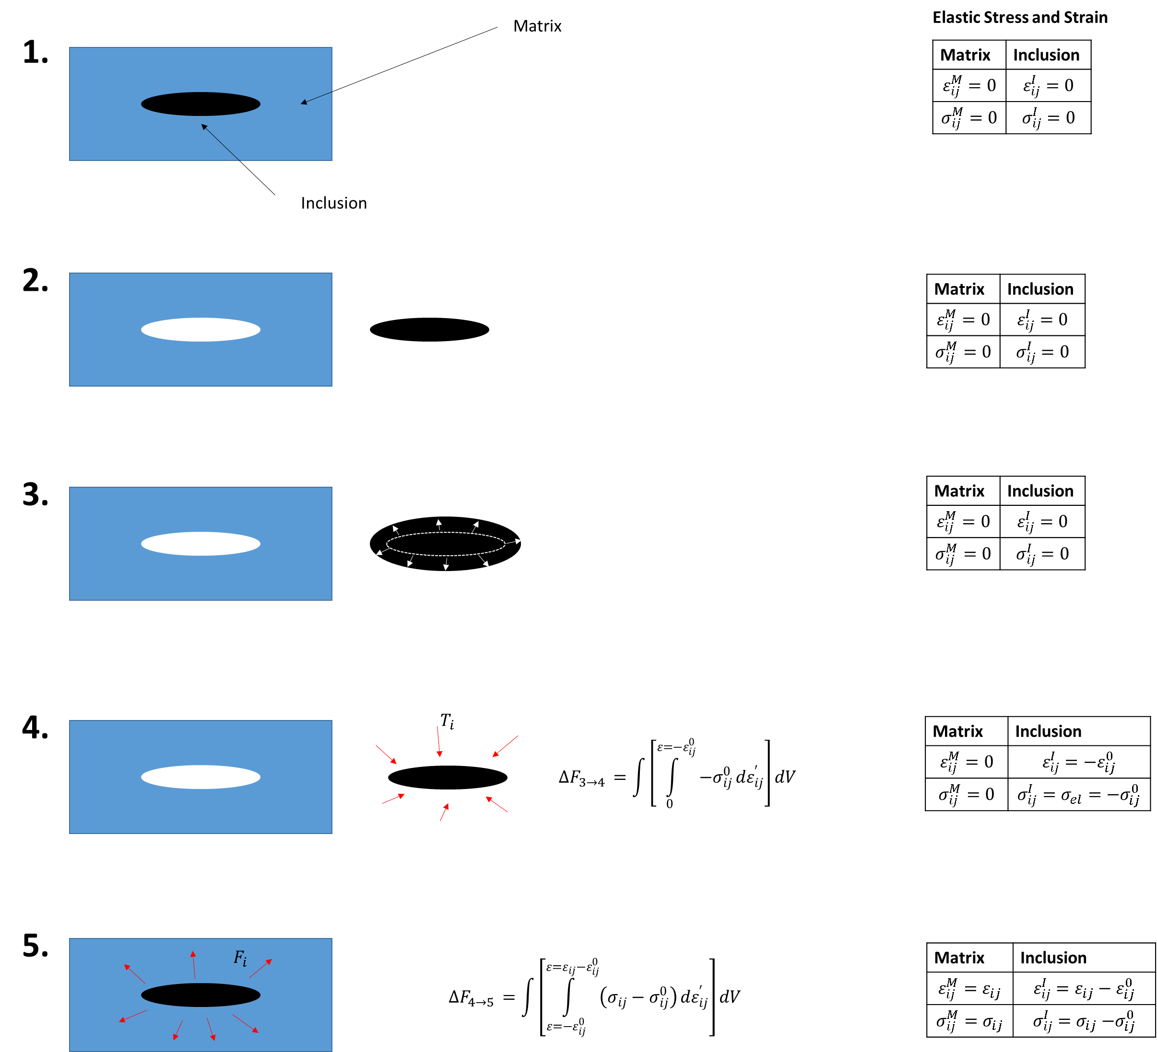

The only nonzero free energy changes occur between steps 3 and 4 and steps 4 and 5. The integral in step 4 (the energy change between steps 3 and 4) is:

$$∆F_{3→4}=\int{\left[\int_{0}^{ε={-ε}_{ij}^{0}}{-σ_{ij}^{0}}dε_{ij}^{'}\right]}dV=\frac{1}{2}\int{ε_{ij}^{0}σ_{ij}^{0}}dV$$

The integral in step 5 (the energy change between steps 4 and 5) is:

$$∆F_{4→5}=\int{\left[\int_{ε=-ε_{ij}^{0}}^{ε=ε_{ij}{-ε}_{ij}^{0}}{\left(σ_{ij}-σ_{ij}^{0}\right)}dε_{ij}^{'}\right]}dV=-\int{\left[\int_{ε=0}^{ε={-ε}_{ij}^{0}}{\left(σ_{ij}-σ_{ij}^{0}\right)}dε_{ij}^{'}\right]}dV+\int{\left[\int_{ε=0}^{ε=ε_{ij}{-ε}_{ij}^{0}}{\left(σ_{ij}-σ_{ij}^{0}\right)}dε_{ij}^{'}\right]}dV=-\frac{1}{2}\int{ε_{ij}^{0}σ_{ij}^{0}}dV+\frac{1}{2}\int{C_{ijkl}\left(ε_{ij}{-ε}_{ij}^{0}\right)\left(ε_{kl}{-ε}_{kl}^{0}\right)}dV$$

The total free energy is:

$$∆F=∆F_{3→4}+∆F_{4→5}=\frac{1}{2}\int{C_{ijkl}\left(ε_{ij}{-ε}_{ij}^{0}\right)\left(ε_{kl}{-ε}_{kl}^{0}\right)}dV$$

We could also consider the change from step 1 to step 5, in which case the elastic strain changes as: $ε_{ij}=0→ε_{ij}{-ε}_{ij}^{0}$ and the stress changes as: $σ_{ij}=0→σ_{ij}{-σ}_{ij}^{0}$.

The elastic free energy is therefore:

$$F_{e}=\frac{1}{2}\int{C_{ijkl}\left(ε_{ij}{-ε}_{ij}^{0}\right)\left(ε_{kl}{-ε}_{kl}^{0}\right)}dV$$

**Alternate Definition of Elastic Strain Energy**

Substitution of the total strain ($ε_{ij}={\overline{ε}}_{ij}+{δε}_{ij}$) into the elastic energy equation gives [Yu U Wang, Phase field microelasticity theory and modeling of elastically and structurally inhomogeneous solids, JAP 92 1351)].

$$F_{e}=\int{C_{ijkl}\left(ε_{ij}-ε_{ij}^{0}\right)\left(ε_{kl}-ε_{kl}^{0}\right)}dV+=\int{\frac{1}{2}C_{ijkl}ε_{ij}^{0}ε_{kl}^{0}-C_{ijkl}{{\overline{ε}}_{ij}ε}_{kl}^{0}+\frac{1}{2}C_{ijkl}{\overline{ε}}_{ij}{\overline{ε}}_{kl}+\left[-C_{ijkl}δε_{ij}ε_{kl}^{0}+C_{ijkl}{\overline{ε}}_{ij}δε_{kl}+\frac{1}{2}C_{ijkl}δε_{ij}δε_{kl}\right]}dV$$

$$F_{e}=\int{\frac{1}{2}C_{ijkl}ε_{ij}^{0}ε_{kl}^{0}}dV-{\overline{ε}}_{ij}\int{C_{ijkl}ε_{kl}^{0}}dV+\int{\frac{1}{2}C_{ijkl}{\overline{ε}}_{ij}{\overline{ε}}_{kl}}dV+\int{-C_{ijkl}δε_{ij}ε_{kl}^{0}+C_{ijkl}{\overline{ε}}_{ij}δε_{kl}+\frac{1}{2}C_{ijkl}δε_{ij}δε_{kl}}dV$$

$$\int{\frac{1}{2}C_{ijkl}{\overline{ε}}_{ij}{\overline{ε}}_{kl}}dV=\frac{V}{2}C_{ijkl}{\overline{ε}}_{ij}{\overline{ε}}_{kl}$$

The following simplifies because $\int{δε_{kl}}dV=0.$

$$\int{-C_{ijkl}δε_{ij}ε_{kl}^{0}+C_{ijkl}{\overline{ε}}_{ij}δε_{kl}+\frac{1}{2}C_{ijkl}δε_{ij}δε_{kl}}dV=\int{-C_{ijkl}ε_{kl}^{0}δε_{ij}+\frac{1}{2}C_{ijkl}δε_{ij}δε_{kl}}dV$$

The total elastic strain energy is therefore:

$$F_{e}=\int{\frac{1}{2}C_{ijkl}ε_{ij}^{0}ε_{kl}^{0}}dV-{\overline{ε}}_{ij}\int{C_{ijkl}ε_{kl}^{0}}dV+\frac{V}{2}C_{ijkl}{\overline{ε}}_{ij}{\overline{ε}}_{kl}+\int{\frac{1}{2}C_{ijkl}δε_{ij}δε_{kl}-C_{ijkl}ε_{kl}^{0}δε_{ij}}dV=F_{squeeze}+F_{relax}^{hom}+F_{relax}^{het},$$

with

$$F_{squeeze}=\int{\frac{1}{2}C_{ijkl}ε_{ij}^{0}ε_{kl}^{0}}dV$$

$$F_{relax}^{het}=\int{\frac{1}{2}C_{ijkl}δε_{ij}δε_{kl}-C_{ijkl}ε_{kl}^{0}δε_{ij}}dV$$

$$F_{relax}^{hom}=\int{\frac{1}{2}C_{ijkl}{\overline{ε}}_{ij}{\overline{ε}}_{kl}-C_{ijkl}ε_{kl}^{0}{\overline{ε}}_{ij}}dV=\frac{V}{2}C_{ijkl}{\overline{ε}}_{ij}{\overline{ε}}_{kl}-{\overline{ε}}_{ij}\int{C_{ijkl}ε_{kl}^{0}}dV$$

Within Eshelby’s method of inclusions, the total elastic energy is split into three components. The squeeze energy is the energy needed to squeeze the stress-free variants back into the matrix. The homogenous and heterogeneous relaxation energies are due to the relaxations of the system from the squeezed case (that is still stress-free, it has just been placed back into the matrix) into the new elastic equilibrium [Y. Wang and A.G.Khachaturyan, Three-dimensional field model and computer modeling of martensitic transformations, Acta. Materi 45 2, 1997]. [YM Jin, A Artemev, AG Khachaturyan, Three-dimensional phase field model of low symmetry martensitic transformation in polycrystal, Acta Materialia 49 (2001) 2309].

This form of the elastic energy is interesting in that it separates the homogenous and heterogeneous strain terms. Each of the homogenous and heterogeneous strain terms adds to the energy through an elastic and an electrostrictive contribution.

**Energy Minimization Mechanical Equilibrium**

Another method of deriving the mechanical equilibrium condition is to minimize the elastic free energy with respect to the displacement field. We consider an elastic tensor that is independent of spatial position.

The total elastic free energy is:

$$F_{e}=F_{squeeze}+F_{relax}^{hom}+F_{relax}^{het},$$

where the heterogeneous relaxation free energy is:

$$F_{relax}^{het}=\int{-\frac{1}{2}C_{ijkl}\left(u_{i,j}+u_{j,i}\right)ε_{kl}^{0}+C_{ijkl}{\overline{ε}}_{ij}δε_{kl}+\frac{1}{2}C_{ijkl}\left(\frac{1}{2}\left(u_{i,j}+u_{j,i}\right)\right)\left(\frac{1}{2}\left(u_{k,l}+u_{l,k}\right)\right)}dV=\int{∂f_{relax}^{het}}dV$$

Taking the variational derivative with respect to displacement field leads to:

$$\frac{δF}{δu_{i}}=\frac{δF_{e}}{δu_{i}}=\frac{δF_{relax}^{het}}{δu_{i}}=\frac{∂f_{relax}^{het}}{∂u_{i}}-\left(\frac{∂}{∂x_{1}}\frac{∂f_{relax}^{het}}{∂u_{i,1}}+\frac{∂}{∂x_{2}}\frac{∂f_{relax}^{het}}{∂u_{i,2}}+\frac{∂}{∂x_{3}}\frac{∂f_{relax}^{het}}{∂u_{i,3}}\right)$$

Using the simplifications,

$$\frac{∂f_{relax}^{het}}{∂u_{i}}=0$$

$$\frac{∂}{∂x_{j}}\frac{∂f_{relax}^{het}}{∂u_{i,j}}=\frac{∂}{∂x_{1}}\frac{∂f_{relax}^{het}}{∂u_{i,1}}+\frac{∂}{∂x_{2}}\frac{∂f_{relax}^{het}}{∂u_{i,2}}+\frac{∂}{∂x_{3}}\frac{∂f_{relax}^{het}}{∂u_{i,3}},$$

we get

$$\frac{δF}{δu_{i}}=\frac{∂}{∂x_{j}}\frac{∂f_{relax}^{het}}{∂u_{i,j}}.$$

Evaluating the first term of $F_{relax}^{het}:$

$$\frac{∂}{∂u_{i,j}}\left(u_{i,j}+u_{j,i}\right)=2$$

$$\frac{∂}{∂x_{j}}\frac{∂}{∂u_{i,j}}\left[-\frac{1}{2}C_{ijkl}\left(u_{i,j}+u_{j,i}\right)ε_{kl}^{0}\right]=\frac{∂}{∂x_{j}}\left[-C_{ijkl}ε_{kl}^{0}\right]=-C_{ijkl}ε_{kl,j}^{0}$$

The second term of $F_{relax}^{het}$ does not depend on $u_{i,j}.$

Evaluating the second term of $F_{relax}^{het}:$

$$\frac{∂}{∂u_{i,j}}\left(\frac{1}{2}\left(u_{i,j}+u_{j,i}\right)\right)\left(\frac{1}{2}\left(u_{k,l}+u_{l,k}\right)\right)=\left[\frac{∂}{∂u_{i,j}}\left(\frac{1}{2}\left(u_{i,j}+u_{j,i}\right)\right)\right]\left(\frac{1}{2}\left(u_{k,l}+u_{l,k}\right)\right)+\left[\frac{∂}{∂u_{i,j}}\left(\frac{1}{2}\left(u_{k,l}+u_{l,k}\right)\right)\right]\left(\frac{1}{2}\left(u_{i,j}+u_{j,i}\right)\right)=\left(\frac{1}{2}\left(u_{k,l}+u_{l,k}\right)\right)+\left(\frac{1}{2}\left(u_{i,j}+u_{j,i}\right)\right)$$

$$\frac{∂}{∂x_{j}}\frac{∂}{∂u_{i,j}}\left[\frac{1}{2}C_{ijkl}\left(\frac{1}{2}\left(u_{i,j}+u_{j,i}\right)\right)\left(\frac{1}{2}\left(u_{k,l}+u_{l,k}\right)\right)\right]=\frac{1}{4}\frac{∂}{∂x_{j}}C_{ijkl}\left(u_{k,l}+u_{l,k}+u_{i,j}+u_{j,i}\right)=C_{ijkl}u_{k,lj}$$

$$C_{ijkl}u_{k,l}=C_{ijkl}u_{l,k}=C_{ijkl}u_{i,j}=C_{ijkl}u_{j,i}$$

Therefore,

$$\frac{δF}{δu_{i}}=0$$

leads to $C_{ijkl}u_{k,lj}=C_{ijkl}ε_{kl,j}^{0}.$

**Mechanical Equilibrium and Mechanical Boundary Conditions**

We have two order parameters in our elastic energy: strain and polarization. To eliminate the strain order parameter, we solve $C_{ijkl}u_{k,lj}=C_{ijkl}ε_{kl,j}^{0}.$ We can apply boundary conditions to the displacement field for different physical scenarios. Periodic boundary conditions in all three Cartesian axes adequately simulate a bulk single crystal.

For a thin film scenario, the thin film/substrate interface is assumed to be coherent. The substrate is assumed to be infinitely thick, and beyond a certain distance into the substrate ($h_{sub}$), the substrate does not undergo any elastic deformation…. More stuff.

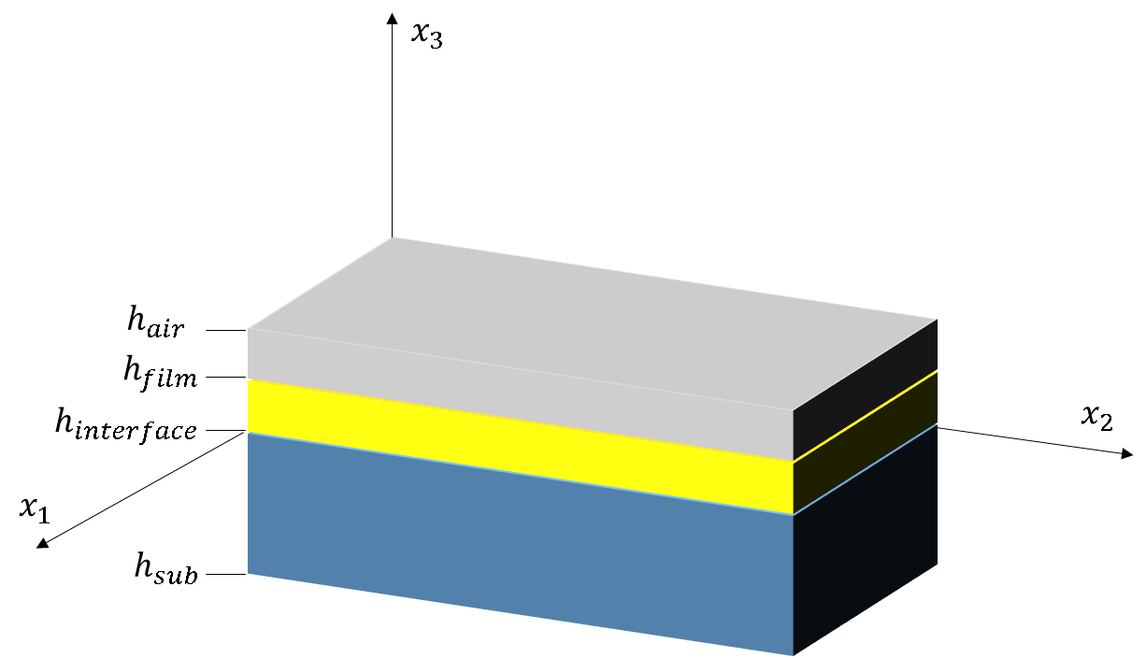

The eigenstrain is nonzero only within the film portion. Polarization is nonzero only within the film.

$$ε_{kl}^{0}=\left\{\begin{matrix}0,h<h_{sub} \\ ε_{kl},h_{sub}<h<h_{film} \\ 0,h>h_{film}\end{matrix}\right.$$

For a thin film, we can apply periodic boundary conditions in $x_{1},x_{2}$. We apply the following boundary conditions along $x_{3}$:

$$u_{1}\left(x_{1},x_{2},x_{3}=h_{sub}\right)=0$$

$$u_{2}\left(x_{1},x_{2},x_{3}=h_{sub}\right)=0$$

$$u_{3}\left(x_{1},x_{2},x_{3}=h_{sub}\right)=0,$$

and

$$δσ_{i3}\left(x_{1},x_{2},x_{3}=h_{film}\right)=0$$

$${\left.δσ_{i3}\right|}_{h=h_{film}}={\left.\left(C_{i3kl}\left(u_{k,l}-ε_{kl}^{0}\right)\right)\right|}_{h=h_{film}}$$

We must also apply boundary conditions to the homogenous stress and strain. The homogenous strain is set to be ( $U_{s}$ is the misfit strain):

$${\overline{ε}}_{11}={\overline{ε}}_{22}=U_{s}$$

$${\overline{ε}}_{12}=0$$

The homogenous stress is set to be zero:

$${\overline{σ}}_{12}={\overline{σ}}_{13}={\overline{σ}}_{33}=0$$

We can set the homogenous stresses ${\overline{σ}}_{i3}$ to zero by minimizing the free energy with respect to the homogenous strain. The variation derivative simplifies to a partial derivative because ${\overline{ε}}_{ij}$ is a constant (Hong Liang Hu 3D Phase Field <http://www.ems.psu.edu/~lqc3/publications/HLHu1998JACerS_ferroelectric3D.pdf> …):

We could also set (YuLuanLi Acta Mater 2002):

$$C_{i3kl}{\overline{ε}}_{kl}=0$$

${\overline{σ}}_{i3}=C_{i3kl}{\overline{ε}}_{kl}=0$ gives us three equations:

$$2C_{44}{\overline{ε}}_{31}=0$$

$$2C_{44}{\overline{ε}}_{32}=0$$

$$C_{12}{\overline{ε}}_{11}+C_{12}{\overline{ε}}_{22}+C_{44}{\overline{ε}}_{33}=0→{\overline{ε}}_{33}=-\frac{C_{12}{\overline{ε}}_{11}+C_{12}{\overline{ε}}_{22}}{C_{44}}$$